Arithmetic Circuit
The arithmetic microoperations can be implemented in one composite arithmetic circuit. The basic component of an arithmetic circuit is the parallel adder. By controlling the data inputs to the adder, it is possible to obtain different types of arithmetic operations.
The diagram of a 4-bit arithmetic circuit is shown in fig 4-9. It has four full-adder circuits that constitute the 4-bit adder and four multiplexers for choosing different operations. There are two 4-bit inputs A and B and a 4-bit output D.
The four inputs from A go directly to the X inputs of the binary adder. Each of the four inputs from B are connected to the data inputs of the multiplexers. The multiplexers data inputs also receive the complement of B. The other two data inputs are connected to logic-0 and logic-1. Logic-0 is a fixed voltage value for integrated circuits and Logic-1 signal can be generated through an inverter whose input is 0. The four multiplexers are controlled by two selection inputs, S₁ and S_{0.} The input carry C_{in} goes to the carry input of the FA in the least significant position. The other carries are connected from one stage to the next.
The output of the binary adder is calculated from the following arithmetic sum:
D = A+Y+C_{in.}
Where A is the 4- bit binary number at the X inputs and Y is the 4-bit binary number at the Y inputs of the binary adder. C_{in} is the input carry, which can be equal to 0 or 1.
Addition:
When S₁S_{0.} = 00, the value of B is applied to the Y inputs of the adder. If C_{in}=0, the output D = A+B. If C_{in}=1, output D = A+B+1.
Subtraction:
When S₁S_{0.} = 01, the complement of B is applied to the Y inputs of the adder. If C_{in}=1, the output D = A+B’+1 which is equal to A-B. If C_{in}=0, output D = A+B’.
Increment:
When S₁S_{0.} = 10, the inputs from B are neglected and all 0’s are inserted into the Y inputs. The output becomes D= A+0+ C_{in}. This gives D = A when C_{in} = 0 and D = A+1 when C_{in}=1.
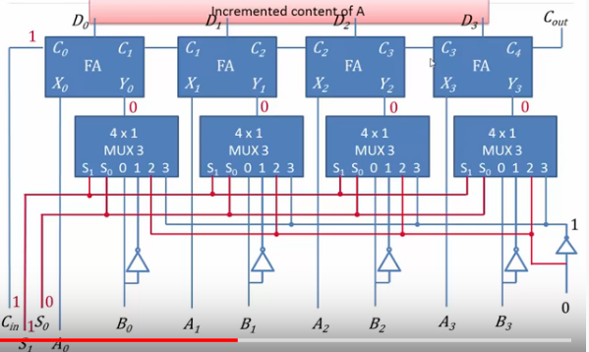(No need to draw this again. Only for understanding.)
Decrement:
When S₁S_{0.} = 11, all 1’s are inserted into Y inputs of the adder to produce the decrement operation D = A-1 when C_{in}=0. This is because a number with all 1’s is equal to the 2’s complement of 1. The 2’s complement of binary 0001 is equal to 1111. Adding a number A to the 2’s complement of 1 produces F = A+2’s complement of 1= A-1.
When C_{in}=1, then D = A-1+1 =A, which causes a direct transfer from input A to output D.

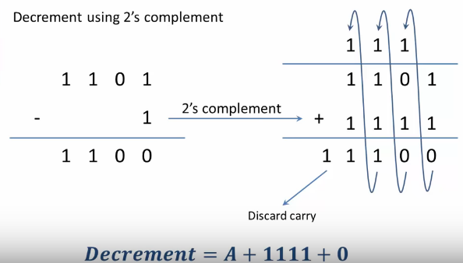
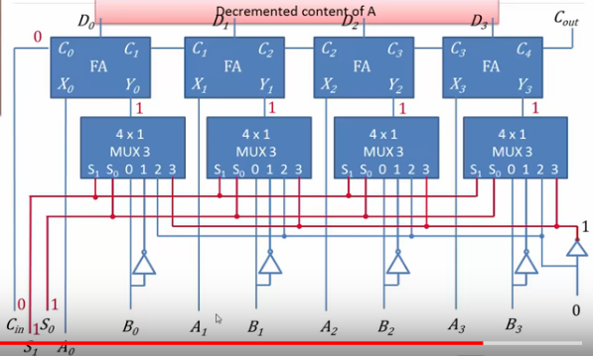(Only for understanding. No need to draw again)

